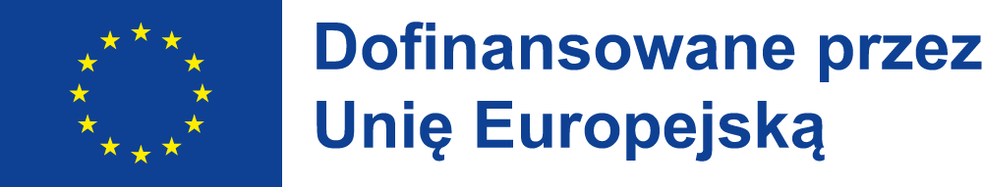


LESSON PLAN

Citizenship Education

Class details:
age: 10-15 years old
number of learners: 16-28

AIMS:
- My learners will get to know the concept of citizenship education.
- My learners will get to know why citizenship education is important.
- My learners will create a list of events for local community that they could organize.

ASSUMED KNOWLEDGE:
- My learners should know what students council is.

TEACHING AIDS:
Power Point presentation, YouTube videos, pieces of paper.

PROCEDURE:

LEAD–IN:
The teacher asks students whether they heard about students council.
The teachers asks students what kind of activities students council organizes in their school.

approximate time: 5 minutes
type of interaction: teacher – students, students – teacher
purpose: checking whether students know about students council events

task 1:
The teacher presents students the Power Point presentation about the citizenship education in schools and local communities.

approximate time: 15 minutes
type of interaction: teacher – students, students – teacher
purpose: introducing students to the concept of citizenship education

task 2:
The teacher asks students to watch and read examples of citizenship education in European Union.

approximate time: 10 minutes
type of interaction: teacher – students, students – teacher, students – students
purpose: showing students how use citizenship education to help their schools and local communities

task 3:
The teacher asks students to make a list of activities and events that they as students could organize or take part in with having in mind the needs of their local communities.

approximate time: 15 minutes
type of interaction: teacher – students, students – teacher, students – students
purpose: checking whether students have understood everything correctly

summary:
The teacher summarizes the most important elements of citizenship education and asks students why it is important to be a part of local community.

approximate time: 5 minutes
type of interaction: teacher – students, students – teacher
purpose: checking whether students have understood everything correctly and summarizing the purpose of citizenship education

Publikacja została sfinansowana ze środków UE. Wyrażone poglądy i opinie są jedynie opiniami autora lub autorów i niekoniecznie odzwierciedlają poglądy i opinie Unii Europejskiej lub Narodowej Agencji (NA). Unia Europejska ani NA nie ponoszą za nie odpowiedzialności.

