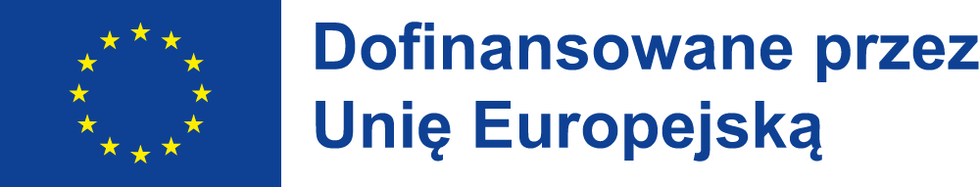


LESSON PLAN

Nonviolent Communication

Class details:
age: 10-15 years old
number of learners: 16-28

AIMS:
- My learners will get to know the concept of nonviolent communication.
- My learners will get to know why nonviolent communication is important.
- My learners will practice transforming sentences into nonviolent communication.

ASSUMED KNOWLEDGE:
- My learners should know what sentence transformation is.

TEACHING AIDS:
Power Point presentation, YouTube videos, copies of exercises.

PROCEDURE:

LEAD–IN:
The teacher asks students whether they heard about nonviolent communication.
The teachers asks student what kind of animals are a giraffe and a jackal.

approximate time: 5 minutes
type of interaction: teacher – students, students – teacher
purpose: checking whether students have heard about NVC

task 1:
The teacher presents students the Power Point presentation about the nonviolent communication and discusses all the stages of it.

approximate time: 15 minutes
type of interaction: teacher – students, students – teacher
purpose: introducing students to the concept of nonviolent communication

task 2:
The teacher asks students to watch and read examples of sentence transformation from the jackal language into the giraffe language.

approximate time: 10 minutes
type of interaction: teacher – students, students – teacher, students – students
purpose: showing students how to transform sentences into NVC

task 3:
The teacher asks students to do the transformation task themselves to practice the nonviolent communication.

approximate time: 15 minutes
type of interaction: teacher – students, students – teacher, students – students
purpose: checking whether students have understood everything correctly

summary:
The teacher summarizes the most important elements of nonviolent communication and asks students why it is important to use such language of communication.

approximate time: 5 minutes
type of interaction: teacher – students, students – teacher
purpose: checking whether students have understood everything correctly and summarizing the purpose of NVC

Publikacja została sfinansowana ze środków UE. Wyrażone poglądy i opinie są jedynie opiniami autora lub autorów i niekoniecznie odzwierciedlają poglądy i opinie Unii Europejskiej lub Narodowej Agencji (NA). Unia Europejska ani NA nie ponoszą za nie odpowiedzialności.

